**Impact of Global Warming on Natural SST Variability from CCSM4 and Observations**

Dong-Ping Wang[1], Dake Chen[2], Minghua Zhang1

email: dong-ping.wang@stonybrook.edu

**Abstract**

The global nonseasonal sea surface temperature (SST) pattern during the recent warming period is examined from observations and the NCAR Community Climate System Model version 4 (CCSM4) simulations of the fifth phase of the Coupled Model Intercomparison Project (CMIP5). An extended Empirical Orthogonal Function (EEOF) analysis with a sliding window of five seasons is used to obtain the spatio-temporal SST structures. The dominant global SST variability is associated with a canonical El Nino mode and a transition phase. The canonical mode has an apparent weakening trend, athough it has negligible contribution to the global average. The transition mode, on the other hand, shows a warming trend that accounts for the rising global mean temperature. The warming has strong spatial variations. The North Atlantic in particular has warmed up at about three times the global average. This suggests changes of El Nino behavior as a consequence of anthropogenic forcing. For comparison, the model simulates the observed global warming trend. The model also shows modifications of canonical and transition modes in response to external forcing. However, unlike the observations, the model shows a strengthening canonical mode and a ubiquitous warming. The discrepancy could have important policy implication on climate change.

**1. Introduction**

Global sea surface temperatures (SST) from historical ship data and satellite advanced very high resolution radiometer (AVHRR) measurements (since 1982) have shown a gradual warming of Earth's climate in the twentieth century. Figure 1 shows the observed global mean SST with seasonal components removed, based on the UK Met Office Hadley Centre's sea ice and sea surface temperature dataset, HadISST (1870-2012). Also shown is a model global mean SST (1850-2005) from a 'historical' run forced by observed atmospheric composition changes (reflecting both anthropogenic and natural sources), based on the National Center for Atmospheric Research (NCAR) Community Climate System Model Version 4 (CCSM4) in the fifth phase of the Coupled Model Intercomparison Project (CMIP5) (Taylor et al. 2012). The model and observation show a similar warming trend. They also have comparable interannual (3-8 years) SST variations associated with El Nino. (Since El Nino is a natural variability, the timing of individual events from the model generally would not match observations.) El Nino is the dominant global SST variability, and is controlled by a delicate balance of thermal and dynamic feedbacks between atmosphere and ocean in the tropical Indo-Pacific Ocean. An intriguing question that may arise is whether El Nino might interact with rising global mean temperatures. El Nino and its teleconnections could be modified when the tropical climate evolves under global warming (Collins et al. 2013). Since El Nino has enormous influence on the precipitation and temperature worldwide, any positive feedback might amplify the societal impact of a gradually warming climate.

El Nino has large natural variability. Model experiments under controlled external forcing have shown large multidecadal modulations of El Nino behavior (Wittenberg 2009; Deser et al. 2012). Since the instrumental record is relatively short, using observations alone to detect externally forced changes in El Nino behavior would have great difficulty. Indeed, climate diagnostic studies often restrict El Nino phenomenon to the tropical Pacific, which in essence eliminates the possibility of a modified atmospheric teleconnection (Penland and Matrosova, 2006; Thompson et al. 2009; Compo and Sardeshnukh, 2010). An alternative approach is to compare coupled climate model simulations with and without external (anthropogenic) forcing, a technique used in the Intergovernmental Panel on Climate Change (IPCC) reports. With a large ensemble of varying initializations and physics, model's natural variability could in principle be suppressed. On the other hand, while climate models are capable of producing El Nino, it is not clear if the models could also simulate externally forced changes, considering the sensitivity of various feedback mechanisms.

In this study, we use both observations (HadISST) and a climate model (CCSM4) to determine the spatio-temporal patterns of global SST variability. We compare global SST patterns between the naturally forced and externally forced (including both natural causes and anthropogenic activities') model runs. We also compare differences between the naturally forced model run and observations. This allows us to identify potential changes in El Nino behavior due to anthropogenic forcing (Meehl et al. 2009). The analysis is focused on the recent warming since the 1980s when AVHRR-based global SST measurement is available; although the early warming and the interim period are also briefly examined. We choose to treat each climate 'regime' separately, because the characteristics of global SST pattern might not remain invariant in a changing climate. There is also concern about data quality prior to satellite era. The rest of the paper is structured as follows. Section 2 provides a description of model and observations and the analysis method. Section 3 describes the spatio-temporal patterns of global SST from model and observations. Section 4 summarizes the results and discusses outstanding issues with regard to separating natural variability from external forcing.

**2. Data and Methods**

*a. Data*

We use the UK Met Office Hadley Centre's sea ice and sea surface temperature dataset, HadISST, a 1o × 1o high-resolution SST dataset reconstructed from in situ and satellite observations (Rayner et al. 2003). Seasonal means are computed from monthly data, and SST anomalies are formed by removing seasonal cycle, the mean of each season. The gridded SSTs are area weighted by the square root of the cosine of latitude (North 1982). The analysis is over the globe between 70oS and 70oN, retaining the original data resolution. For model data, monthly averaged SST from CCSM4 are obtained for historical (1850-2005) and natural (1850-1998) runs in CMIP5. The historical run is forced by both natural causes such as volcanic eruptions, and human activities, such as fossil fuel burning, and the natural run is by natural causes only. We also use the National Centers for Environmental Prediction/National Center for Atmospheric Research (NCEP/NCAR) Reanalysis (2.5o × 2.5o) for sea level pressure (SLP) and surface wind (Kalnay et al. 1996). The atmospheric data are used only to confirm the results from previous studies which may have used different time period or spatial domain. We do not show results involving atmospheric data.

*b. Methods*

An extended empirical orthogonal function analysis (EEOF) is used in this study. The EEOF is the same as EOF or Principal Component Analysis (PCA), except that the original and its time-lagged fields are concatenated to form an extended dataset. This allows spatial patterns to evolve to capture the spatio-temporal variations. We use a sliding window of 5 seasons for EEOF. The results are similar with a 7-season window. Guan and Nigum (2008) have applied EEOF to study the basin-scale SST variability. Their analysis includes the entire historical dataset (1870 onward), but is restricted to 2/3 of the Pacific basin (20oS - 60oN) with degraded resolution (5o × 2.5o).

The extended dataset is large. For a 30-year record, there are 120 images (seasons) of 360 (longitudes) × 700 (latitudes × lags) pixels each. In EOF, the two-dimensional image is converted to a vector, resulting in a very high-dimensional data. For computational efficiency, a two-dimensional PCA, the Generalized Low Rank Approximation of Matrices (GLRAM), is adopted in this study (Ye 2005). The spatial data, such as SST or SLP anomalies, are highly organized (spatially coherent). It is feasible to significantly reduce data dimension while maintaining data fidelity. In a two-dimensional PCA, the mean square error (MSE) between original and transformed data matrix is minimized

 (1)

A*i* (r *× c*), , is an image where *r* and *c* denote the number of rows and columns respectively, and *n* is the total number of images. The inner summation is over all matrix elements. In (1), a pair of linear transformations, L (*r × la*) and R (*lb × c*), with orthonomal columns, is sought such that A*i* is projected in a least squares sense onto M*i* (*la × lb*) of a reduced (low) rank, (*la* and *lb*) « (*r* or *c*). In our case, (*la* , *lb*) = (60, 30), leading to more than a100-fold dimension reduction from A*i* to M*i*. Then, EOF is applied to transformed dataset M*i*, , to obtain a set of principal components. Since M*i* is a small fraction of A*i*, GLRAM is much more efficient than applying EOF directly to the original dataset. The two methods give virtually identical results.

**3. Results**

*a. CCSM4*

The historical run shows a gradual rise of global mean temperatures (Fig. 1). There are two periods of sustained temperature rise: a recent warming since 1960, and a brief warming at the beginning of the century. We note that warming trends in model global mean temperature are offset from observations by 10-15 years. Nevertheless, since the model is a controlled experiment, the impact of external forcing can be examined by comparing between historical and natural runs. We focus on a 40-year period from 1960 to 2000 of the recent warming. We first consider the natural run. The global mean temperatures are flat in the natural run (not shown). The first two EEOF modes account for 21 and 14% of total variance respectively. Figure 2 shows corresponding global SST patterns. Both modes are associated with El Nino. Mode 1 shows the canonical El Nino (warm event) pattern of large warming in the tropical central-eastern Pacific surrounded by a 'horse-shoe' cooling pattern spanning from the tropical western Pacific to the mid-latitudes in both hemispheres. The 5-season sequence spans from JJA0 to JJA1. (The first year of a warm event is denoted by a zero year.) The warming peaks in SON0 and DJF1 in the tropical Pacific, but is delayed by a season or two in the tropical North Atlantic, western Indian Ocean, and the Southern Ocean. Mode 1 is almost stationary, and is basically the same as the leading EOF mode, a common definition of the canonical El Nino mode.

Mode 2, which leads Mode 1 by about 3 seasons, is the growth phase of El Nino, marked by transition from cold to warm anomalies in the tropical eastern Pacific. (The opposite polarity of Mode 2 describes the decay phase.) There is a persistent warm band in the eastern-central North Pacific (~ 40oN), associated with a weakening Aleutian low in a cold event (Alexander et al. 2002). The Nino-3.4 index, the area averaged SST anomalies in the equatorial Pacific, 5oS-5oN, 170o-120oW is a common measure of El Nino variability. The first two modes explain 89.0 and 7.3% of Nino-3.4 variance respectively, and together they account for nearly all El Nino variability. Mode 1 defines the general El Nino pattern, while Mode 2 describes the phase transition. The cold tongue index (CT) has a larger area coverage of tropical Pacific from the date line to the coast of South America, 6oS-6oN, 180o-90oW (Zhang et al. 1997). In terms of CT, the percentage variances explained are 89.4 and 8.5% respectively.

To see how global SST patterns are modified by anthropogenic forcing, we repeat the same calculations with a historical run of the same period (1960-2000), recalling that the mean global temperature increases substantially during this period (Fig. 1). Figure 3 shows SST patterns of the first three EEOF modes, which account for 21.4, 12.4 and 11.3% of total variance respectively. The first two modes are similar to the natural run, corresponding to the canonical mode and the transition (growth) mode respectively. There are some subtle changes, for example, in Mode 1, warm anomalies are enhanced in the Gulf of Alaska and the Southern Ocean, and in Mode 2, warm anomalies become more pronounced in the central North Pacific. The third mode, on the other hand, is substantially different from the natural run. It shows a ubiquitous warming everywhere except at the eastern tropical Pacific where the El Nino transition (decay) is prevalent.

Figure 4 shows principal components (PCs) of the first three EEOF modes together with the Nino-3.4 index. The first three modes account for most of CT variance; the percentage error variances are 8.4, 6.0, and 2.6 %, with one, two, and three modes respectively. However, while there is no apparent trend in Nino-3.4, Modes 1 and 3 both have a warming trend. To examine if the global temperature rise is associated with these two modes, we compare model global mean temperature with that reconstructed from the first three modes (not shown). The agreement is excellent; the variances explained are 36.8, 43.9, and 98.8% with one, two and three modes respectively. Mode 3 of a widespread warming is the most dominant, explaining about 55% of the variance and 2/3 of the trend of global mean temperatures. This indicates that the impact of external forcing is mainly through modifications of the transition mode. Mode 1 is also significant. In this case, the spatial pattern is relatively unchanged, but the temporal pattern acquires a warming trend. Since the canonical mode is highly correlated with east-west SLP variability, a strengthened canonical mode would be consistent with a weakened Walker circulation in response to global warming, found in some studies (Held and Soden 2006; Zhang and Song 2006; DiNezio et al. 2013).

*b. Model ensemble*

The CCSM4 historical run includes 6 realizations of different initial conditions. The global mean temperatures are essentially the same in all 6 runs. Thus, despite a small ensemble size, the model's internal variability does not appear to impact the warming trend. However, there are significant variations in the warming pattern. We illustrate with the recent warming period (1960-2000). Table 1 shows the percentage variances of global mean temperatures accounted for with one, two, and three modes respectively. In all 6 runs, the global warming pattern is realized in the first three modes. Run 2 is the base case. In Runs 1, 2, 5 and 6, Mode 3 of widespread warming is dominant. In Runs 3 and 4, on the other hand, Mode 1 of enhanced warming in the Gulf of Alaska is most important.

*c. Observations*

In observations, the recent warming started in the mid-1970s. We use only the satellite era, 1982-2012. Figure 5 shows the first three EEOF modes, which explain 22.3, 12.7, and 9.1% of total variance respectively. Mode 1 shows the canonical pattern of warming in the central-eastern equatorial Pacific and cooling in midlatitudes. Modes 2 and 3 are the transition mode. Mode 3 begins in DJF0 with cold anomalies in the equatorial central-eastern Pacific and warm anomalies at midlatitudes in the North and South Pacific. We note that the warm and cold anomalies have comparable strength, a feature commonly attributed to the Pacific Decadal Oscillation (Zhang et al. 1997). By JJA0, cold anomalies in the equatorial Pacific have transitioned to a warm event, while warm anomalies in the South Pacific diminished. The warm anomalies in the central North Pacific however linger through DJF1. Mode 2 lags Mode 3 by about 3 seasons. It starts in SON0 of a matured warm event. By SON1, the warm event is transitioned to a classical cold event of strong cold anomalies in the equatorial Pacific flanked by weak warm anomalies in midlatitudes. .

Apart from the Pacific, the North Atlantic shows strong, persistent warm anomalies at high and low latitudes through the transition phase. The warming peaks in DJF1, but stays long after the demise of warm event in the equatorial Pacific. In the tropical Indian Ocean, warming begins in the west while it is still cooling in the east, an example of the Indian Ocean Dipole (IDO); In this case, the IDO is part of the global pattern (Saji et al. 1999). The Indian Ocean warming peaks in DJF1, and diminishes in JJA1. The delayed warming in the North Atlantic and Indian Oceans is also seen in the composite of historical El Nino events (Harrison and Larkin 1998; Deser et al. 2010). However, because SST patterns are not stationary during the transition, temperature anomalies in the composite are much weaker than in EEOF modes.

Figure 6 shows principal components of the first three modes; Nino-3.4 is included for reference. The strong warm events of 1982/1983 and 1988/1989 are clearly marked in Nino-3.4. Mode 1 is highly correlated with Nino-3.4 (γ = 0.86). Modes 2 and 3 are also correlated with Nino-3.4 with time lags of 2 (γ = 0.62) and -1 (γ = 0.50) seasons respectively. The first three modes account for about 99% of CT variance. Nino-3.4 has no apparent trend during the past three decades. In contrast, Mode 1 has weakened substantially with a negative slope of -0.049±0.020 per year for standardized PC1 (at 95% confidence interval using a Student *t*-test). In other words, PC1 has decreased by 1.5 standard deviations in three decades. Modes 2 and 3, on the other hand, have become warmer with significant positive slopes of 0.044±0.021 and 0.084±0.016 respectively for standardized PC2 and PC3. Figure 7 compares observed and reconstructed global mean temperatures (averaged over 5 seasons). The variances explained are 3.4, 43.5, and 92.1% with one, two and three modes respectively. In other words, the two transition modes with strong warming in the North Atlantic and central North Pacific, account for most of observed global mean temperature rise. The canonical mode, despite its strong negative trend, has negligible contribution to the global average, as cooling in the equatorial eastern Pacific and along the coasts of North and South America is compensated by warming in the central North and South Pacific.

*d. Early warming period*

The anthropogenic forcing is cumulative as the greenhouse gases increases continuously. There could also be significant multidecadal natural variability. This suggests perhaps a continuously evolving global SST response to external forcing. We repeat the same calculations for the early warming period, 1910-1940. We focus on the observations only. Figure 8 shows the first three EEOF modes, which explain 23.3, 13.2, and 9.4% of total variance respectively. The spatial patterns are similar to the recent warming that strong warming in the North Atlantic remains an outstanding feature. The timing though is shifted so that warming is mainly associated with transition from a warm to a cold event. . For global mean temperatures, the variances explained are 37.9, 87.0, and 94.7% respectively with one, two and three modes. Mode 2 is most important, contributing to about 60% of the variance and 3/4 of the slope. We note that the differences of EEOF modes between the early and recent warming periods could simply be due to data quality. The pre-satellite SST data are built from sparse ship observations of irregular spatio-temporal coverage. For the early warming period, for example, only the North Atlantic has a complete spatial coverage (Solomon et al. 2011). It is likely that the EEOF patterns are contaminated.

To explore whether SST patterns remain invariant in a changing climate, we also compute EEOF modes of the interim period, 1945-1975, when global mean temperatures are flat (Fig. 1). The first two modes correspond to the canonical and transition modes respectively, and are similar to the corresponding SST patterns of the natural run. Mode 3, on the other hand, shows a dipole pattern in the Atlantic Ocean, with cooling in the North Atlantic and warming in the South Atlantic (not shown). The warm and cold anomalies cancel each other, resulting in little change in the global average. Because the dominant SST patterns appear to vary greatly from one period to the other, treating entire twentieth century record in a PCA analysis might lead to some ambiguities (Messie and Chavez 2011).

**4. Discussion**

The question of whether El Nino might respond and feedback to anthropogenic forcing is examined by comparing the model's natural and historical runs with the observed global SST patterns. The global El Nino can be completely specified by a canonical mode and a transition phase. The pattern of the observed canonical mode remains unchanged, while the pattern of the transition mode is significantly modified with strong temperature anomalies in the North Atlantic and the central North Pacific. The transition mode moreover indicates a strong warming trend that accounts for the observed global mean temperature rise. This suggests that impacts of anthropogenic forcing in global SST are manifest in the changes of El Nino teleconnections. For comparison, the historical run reproduces the observed warming trend. The model however shows a widespread warming, lacking the highly non-uniform spatial structure found in the observations.

The observations indicate a strong negative trend of canonical mode, which is consistent with a strengthening Walker circulation during the past three decades (McPhaden et al. 2011; L'Heureux et al. 2013). This trend is also consistent with the vanishing classical warm events in the equatorial Pacific since the 2000s (Fig. 6) (Asohk et al. 2007; Kug et al. 2009). From the global perspective, cooling in the tropical Pacific is compensated by warming in midlatitudes, and the negative trend has little effect on global mean temperatures. A weakening canonical mode might be a natural cycle (Wang et al. 2013), or it could be a response to anthropogenic forcing. The observations could not isolate the multidecadal variability. The model runs are also too short (Deser et al. 2012). We note however that the model suggests a strengthening canonical mode in response to external forcing.

The Atlantic Multidecadal Oscillation (AMO) is commonly described by the AMO index, the North Atlantic mean temperature minus the global mean (Trenberth and Shea, 2006; Ting et al. 2009; Deser et al. 2012). (Ting et al. used the model-derived North Atlantic mean temperature, which is basically the same as the observed global mean temperature.) This leads to a common belief that the sharp rise of North Atlantic SST in the past three decades is mainly an internal variability (Delworth and Mann, 2000; Knight 2009). However, subtracting a global mean or a linear trend is ad hoc, which does not completely remove the externally forced response in the North Atlantic. To see how much the North Atlantic warming could be attributed to the global pattern, we compare observed North Atlantic mean temperature (averaged over 5 seasons) with that reconstructed from the first three global EEOF modes (Fig. 7). The two time series are very similar; the variances explained are 13.0, 49.8, and 88.4% with one, two, and three modes respectively. This would suggest that rapid warming in the North Atlantic, about three times the global mean, is merely a spectacular display of a non-uniform warming climate. We obtain a similar result for the early warming period which coincides with another sharp rise of North Atlantic SST.

The present study could have important policy implication on climate change. If the observed global mean temperature rise is due to anthropogenic forcing, climate models might have severely underestimated the potential impact of global warming in the North Atlantic. On the other hand, if observed trends in canonical and transition modes are due to natural (multidecadal) variability, detection and attribution of anthropogenic forcing would become much more complicated. Significant advance in understanding the interaction of natural SST variability with external forcing will be essential in making credible predictions of future climate change.

**Acknowledgements**

We wish to thank I-I. Lin of National Taiwan University for introducing the face recognition method in computer science. DC is supported by grants from National Key Basic Research Program of China (2013CB430302) and National Natural Science Foundation of China (91128204). MZ is supported by the National Science Foundation and the Office of Biological and Environmental Research of the Department of Energy.

Table 1. Percentage variance explained of global mean temperature in the recent warming period, including one, two, and three EEOF modes.

|  |  |  |  |
| --- | --- | --- | --- |
|  | Mode 1 | Mode 1+2 | Mode 1+2+3 |
| Run 1 | 2.8 | 18.3 | 97.2 |
| Run 2 | 36.8 | 43.9 | 98.8 |
| Run 3 | 64.3 | 97.2 | 97.8 |
| Run 4 | 86.5 | 98.9 | 98.9 |
| Run 5 | 29.7 | 41.4 | 99.0 |
| Run 6 | 9.8 | 10.7 | 99.1 |

**References**

Ashok, K., S. K. Behera, S. A. Rao, H. Weng, and Yamagata, T, 2007: El Nino Modoki and its possible teleconnection. *J. Geophys. Res*., **112**, C11007.

Alexander, M. A. and Coauthors, 2002: The Atmospheric Bridge: The influence of ENSO teleconnections on air-sea interaction over the global oceans. *J. Climate,* **15**, 2205-2231.

Collins, M., and Coauthors, 2010; The impact of global warming on the tropical Pacific Ocean and El Nino. *Nature Geo*., **3**, 391-397.

Compo, G., and P.D. Sardeshnukh, 2010: Removing ENSO-related variations from the climate record. *J. Climate,* **23**, 1957-1978.

Delworth T, Mann M. E., 2000: Observed and simulated multidecadal variability in the Northern Hemisphere. *Climate Dyn.* **16**:661–76

Deser, C., M. A. Alexander, S.-P. Xie, and A. S. Phillips, 2010: Sea surface temperature variability: Patterns and mechanisms. *Annu. Rev. Mar. Sci.*, **2**, 115–143.

Deser C. and Coauthors, 2012: ENSO and Pacific Decadal variability in the Community Climate System Model version 4. *J. Climate,* **25**, 2622-2651.

DiNezio, P.N., G.A. Vecchi, and A.C. Clement, 2013: Detectability of changes in the Walker circulation in response to global warming. *J. Climate*, 4038-4048.

Guan, B. & Nigam, S, 2008: Pacific sea surface temperatures in the twentieth century: An evolution-centric analysis of variability and trend. *J. Climate*, **21**, 2790-2809.

Harrison D. E, and Larkin N. K., 1998: El Nino-Southern Oscillation sea surface temperature and wind anomalies, 1946–1993. *Rev. Geophys.,* **36**, 353–399.

Held, I. M., and B. J. Soden, 2006: Robust responses of the hydrological cycle to global warming. *J. Climate*, **19**, 5686–5699.

Kalnay, E., and Coauthors, 1996: The NCEP/NCAR 40-Year Reanalysis Project. *Bull. Amer. Meteor. Soc.,* **77,** 437–471.

Knight, J.R., 2009: The Atlantic Multidecadal Oscillation inferred from the forced climate response in coupled general circulation models. *J. Climate*, **22**, 1610-1625.

L'Heureux, M.L., S. Lee, and Lyon, B., 2013: Recent multidecadal strengthening of the Walker circulation across the tropical Pacific. *Nature Climate Change*, 1-6.

McPhaden, M. J., T. Lee, and McClurg, D., 2011: El Nino and its relationship to changing background conditions in the tropical Pacific Ocean. *Geophys. Res. Lett*., **38,** L15709.

Meehl, G. A., A. Hu, and B. D. Santer, 2009: The mid-1970s climate shift in the Pacific and the relative roles of forced versus inherent decadal variability. *J. Climate,* **22,** 780–792.

Messie, M. and Chavez, F., 2011: Global modes of sea surface temperature variability in relation to regional climate indices. *J. Climate,* **24**:4314-4331.

Nagura, M. and Konda, M., 2007: The seasonal development of an SST anomaly in the Indian Ocean and its relationship to ENSO. *J. Clim*ate, **20**, 38-52.

North, G. R., T. L. Bell, and Cahalan, R. F., 1982: Sampling errors in the estimation of empirical orthogonal function. *Mon. Wea.* *Rev.,* **110,** 669–706.

Penland, C. & Matrosova, L., 2006: Studies of El Nino and interdecadal variability in tropical sea surface temperatures using a nonnormal filter. *J. Clim*ate, **19**, 5796-5815.

Rayner, N. A., and Coauthors, 2003: Global analyses of sea surface temperature, sea ice, and night marine air temperature since the late nineteenth century. *J. Geophys. Res*., **108**, 4407, doi:10.1029/2002JD002670.

Solomon, A., and Coauthors, 2011: Decadal Predictability Working Group, Distinguishing the roles of natural and anthropogenically forced decadal climate variability: Implications for prediction? *Bull. Am. Meteorol. Soc*. **92**, 141-156.

Taylor, K., R.J. Stouffer, and G.A. Meehl, 2012: An overview of CMIP5 and the experimental design. *Bull. Amer. Meteor. Soc.,* **93**, 485-498.

Thompson, D. W. J., Wallace, J. M., Jones, P. D. & Kennedy, J. J., 2009: Identifying signatures of natural climate variability in time series of global-mean surface temperature: Methodology and insights. *J. Clim*ate, **22**, 6120-6141.

Trenberth, K. E., and D. J. Shea, 2006: Atlantic hurricanes and natural variability in 2005. Geophys. Res. Lett., 33, L12704, doi:10.1029/2006GL026894.

Wang, B., and Coauthors, 2013: Northern hemisphere summer monsoon intensified by mega-El Nino/southern oscillation and Atlantic multidecadal oscillation. *Proc. Nat. Aca. Sci*.

Ye, J., 2005: Generalized low rank approximations of matrices. *Machine Learning*, **61**, 167-191.

Zhang, M. H., and H. Song, 2006: [Evidence of Deceleration of Atmospheric Vertical Overturning Circulation over the Tropical Pacific](http://www.agu.org/pubs/crossref/2006/2006GL025942.shtml)*, Geophys. Res. Lett.* 33, L12701, doi:10.1029/2006GL025942.

**Figure legends**

Figure 1. Global mean sea surface temperature anomalies from observations (blue) and CCSM4 historical run (red).

Figure 2. Spatial patterns of the first two EEOF modes from CCSM4 natural run. Each mode spans five seasons referenced to a warm event.

Figure 3. Spatial patterns of the first three EEOF modes from CCSM4 historical run. Each mode spans five seasons referenced to a warm event.

Figure 4. Nino-3.4 index (oC) and principal components (PCs) of the first three EEOF modes from CCSM4 historical run. The PCs have arbitrary scale.

Figure 5. Spatial patterns of the first three EEOF modes from observations. Each mode spans five seasons referenced to a warm event.

Figure 6. Nino-3.4 index (oC) and principal components (PCs) of the first three EEOF modes from observations during the recent warming. The PCs have arbitrary scale.

Figure 7. (left) Global mean sea surface temperature anomalies from observations (red) and reconstructed from first three EEOF modes (blue); (right) North Atlantic mean sea surface temperature anomalies from observations (red) and reconstructed from first three EEOF modes (blue).

Figure 8. Spatial patterns of the first three EEOF modes from observations during the early warming. Each mode spans five seasons referenced to a warm event. For Mode 2, the seasons are referenced to a cold event.

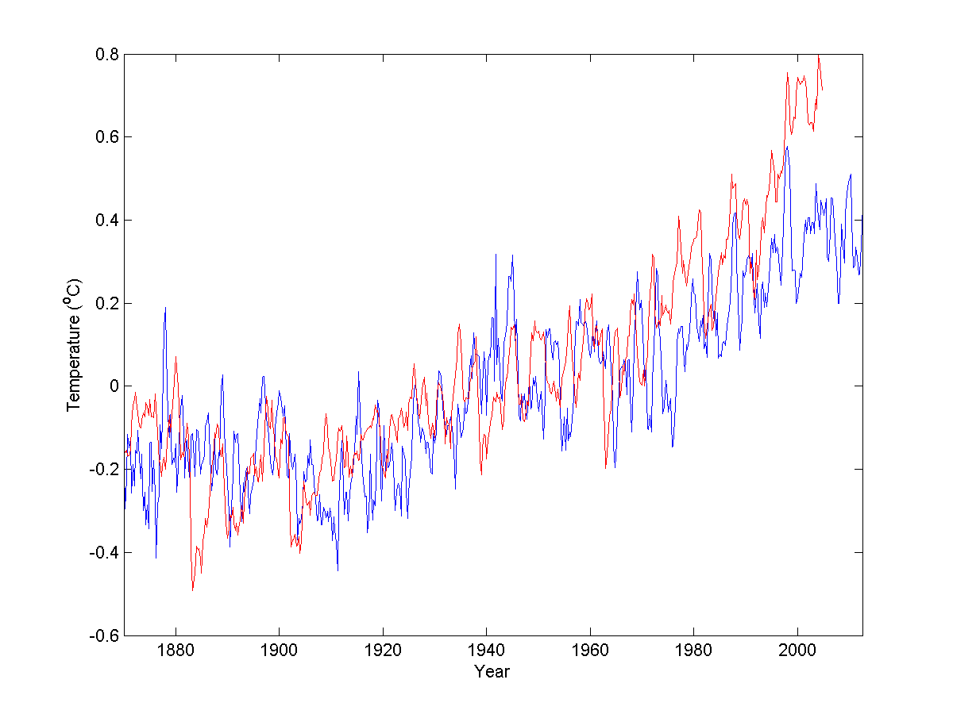

Figure 1. Global mean sea surface temperature anomalies from observations (blue) and CCSM4 historical run (red).

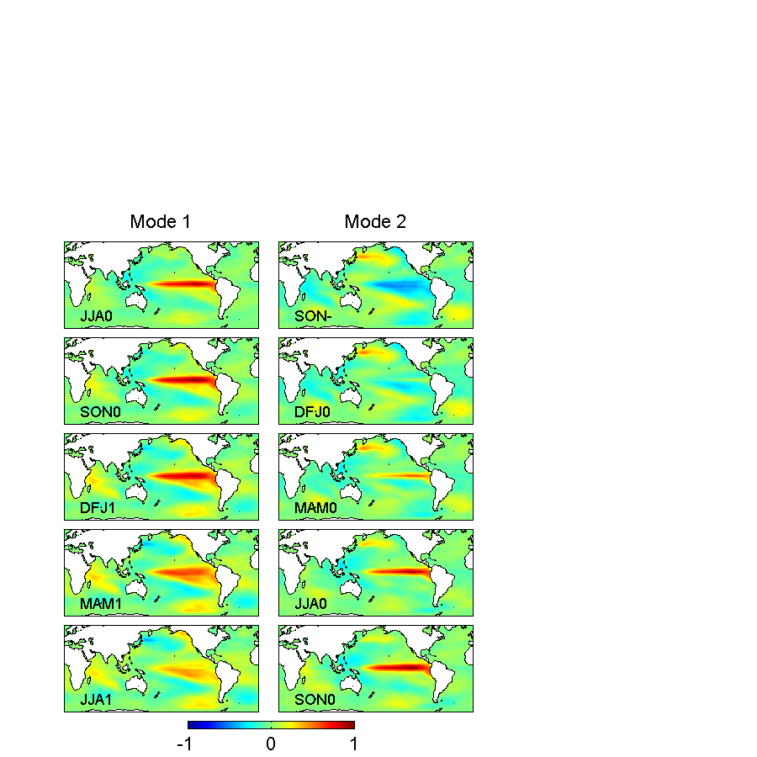

Figure 2. Spatial patterns of the first two EEOF modes from CCSM4 natural run. Each mode spans five seasons referenced to a warm event.

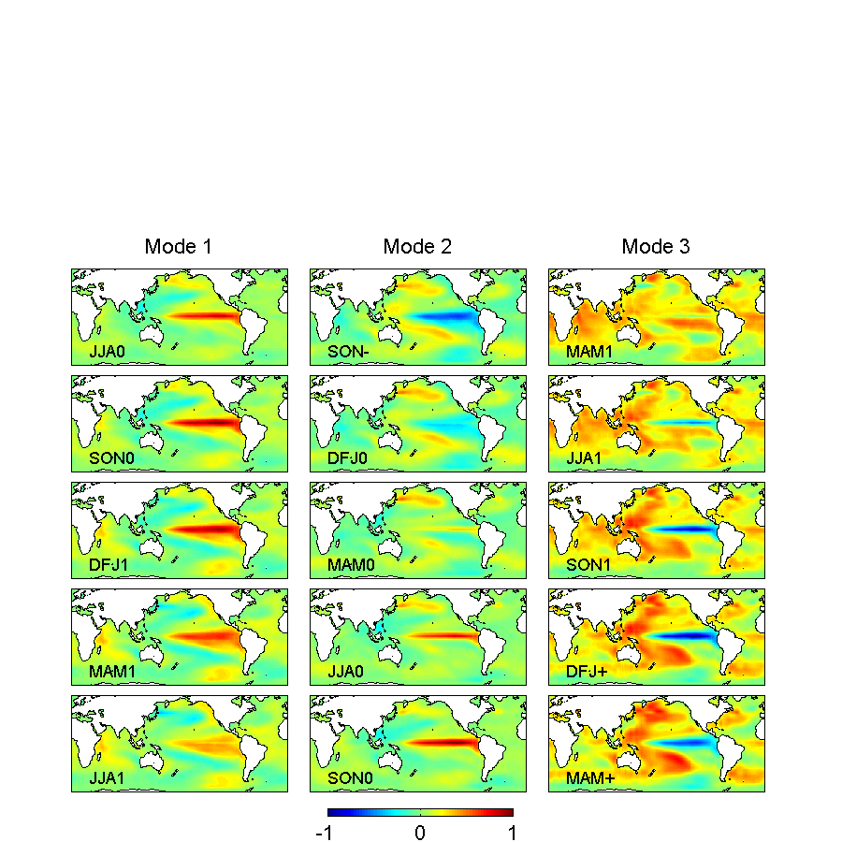

Figure 3. Spatial patterns of the first three EEOF modes from CCSM4 historical run. Each mode spans five seasons referenced to a warm event.

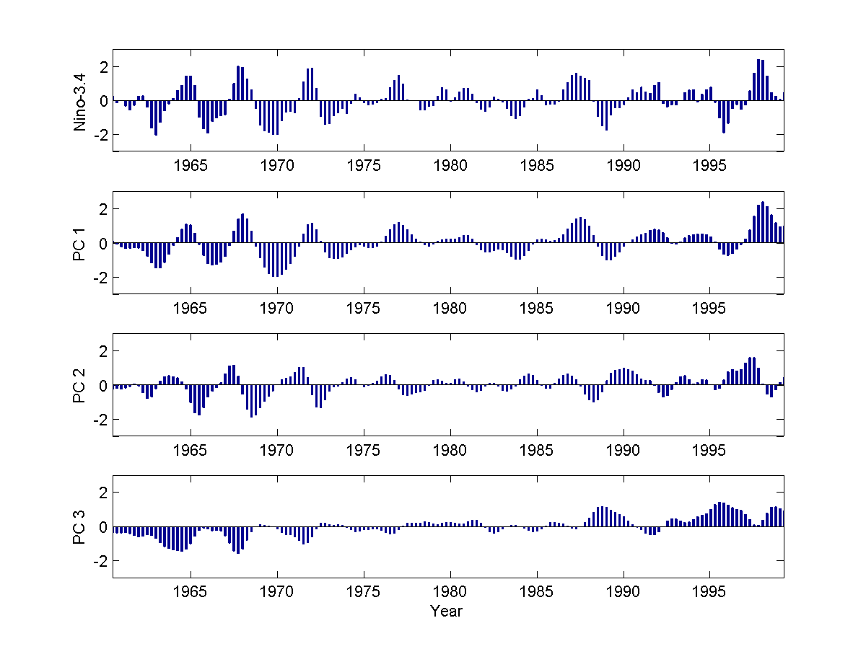

Figure 4. Nino-3.4 index (oC) and principal components (PCs) of the first three EEOF modes from CCSM4 historical run. The PCs have arbitrary scale.

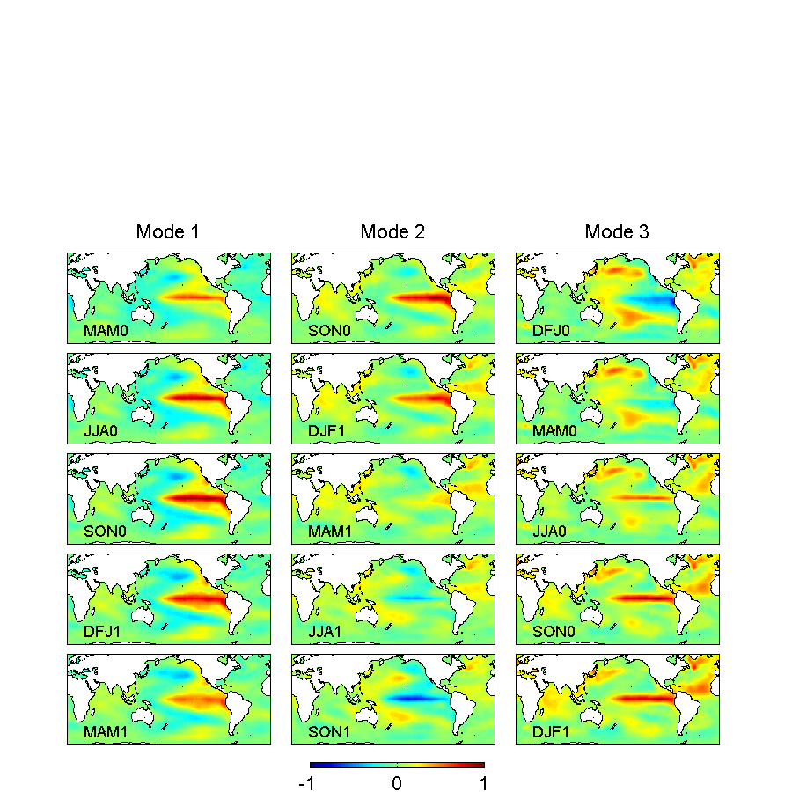

Figure 5. Spatial patterns of the first three EEOF modes from observations during the recent warming. Each mode spans five seasons referenced to a warm event.

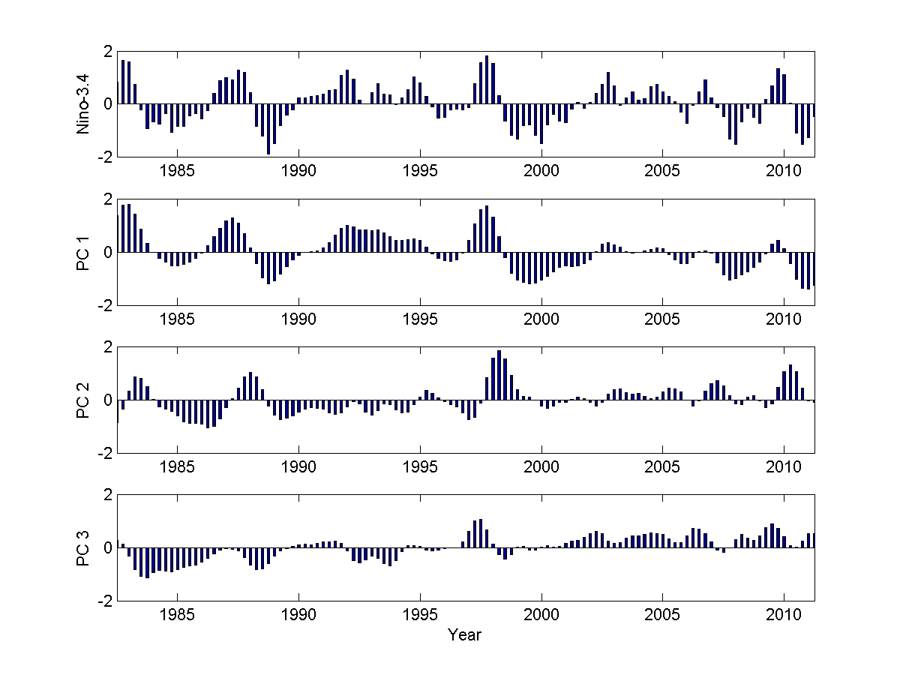

Figure 6. Nino-3.4 index (oC) and principal components (PCs) of the first three EEOF modes from observations. The PCs have arbitrary scale.

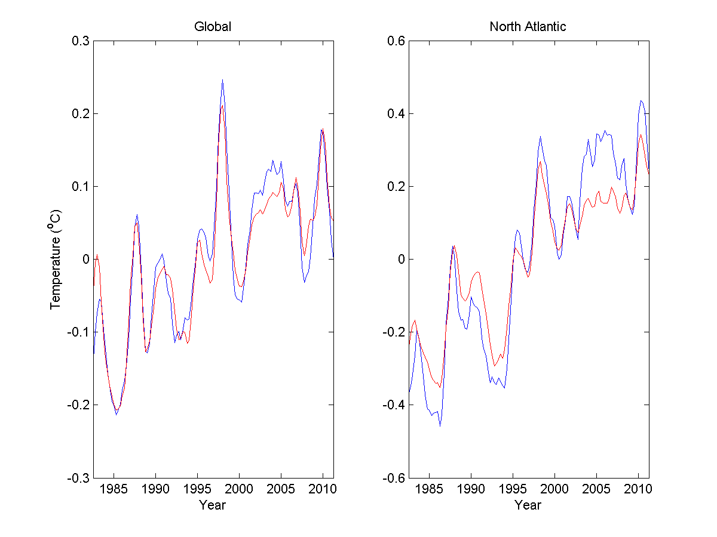

Figure 7. (left) Global mean sea surface temperature anomalies from observations (red) and reconstructed from first three EEOF modes (blue); (right) North Atlantic mean sea surface temperature anomalies from observations (red) and reconstructed from first three EEOF modes (blue).

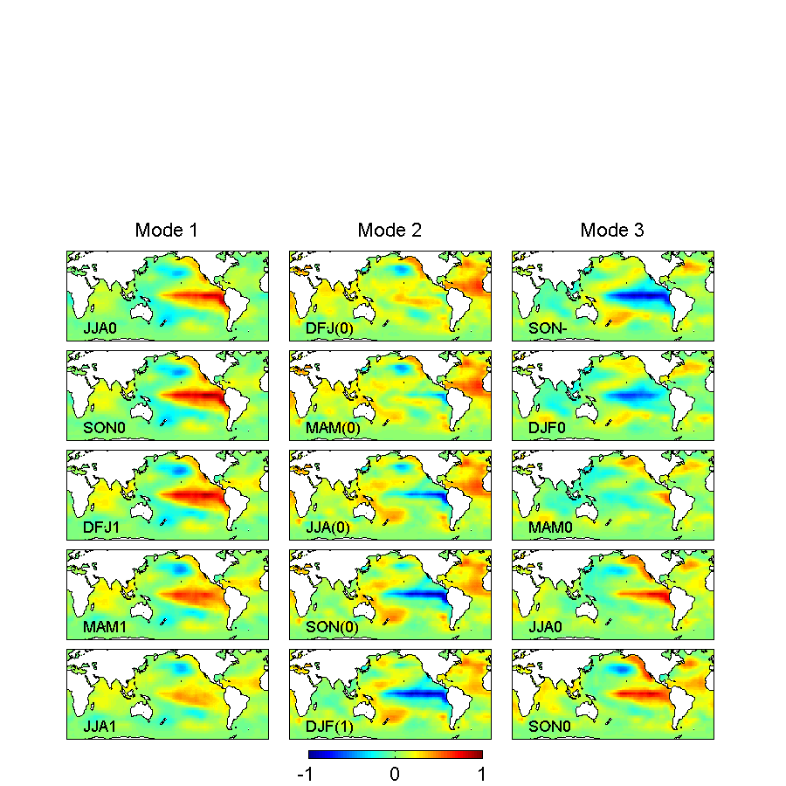

Figure 8. Spatial patterns of the first three EEOF modes from observations during the early warming. Each mode spans five seasons referenced to a warm event. For Mode 2, the seasons are referenced to a cold event.

1. School of Marine and Atmospheric Sciences, Stony Brook University, Stony Brook, New York, USA
2. State Key Laboratory of Satellite Ocean Environmental Dynamics, Second Institute of Oceanography, Hangzhou, China